**COMPUTER NETWORKS ASSIGNMENT**

**DONE BY:**

**SREE VIBOOSHA R**

**RA2211026050079**

**IIIrd B.Tech CSE AIML (A)**

**Exploring Field Test Mode on Smartphones**

1) **Device Types Covered:**

Android Devices (General)

2) **Key Information to Collected in Android Device:**

* **IMEI Number (International Mobile Equipment Identity)**

864562070881937

* **MAC Address (Media Access Control address)**

a8:6f:36:47:e6:bf

* **IP Address (Internet Protocol address)**

2409:40f4:1030:eaa:ecf0:b3ff:febb:b9cf

* **Network Operator/Brand (Name of the cellular provider)**

JIO

* **Network Type (4G LTE, 5G, etc.)**

5G

* **Signal Strength (Measured in dBm)**

108Dbm

* **Download/Upload Bandwidth (Physical channel configuration and speed)**

**DL Bandwidth: 30**

**UL Bandwidth: 15**

* **Mobile Location Information (LAC - Location Area Code and CID - Cell ID)**

LAC = d438 CID = cffea1f

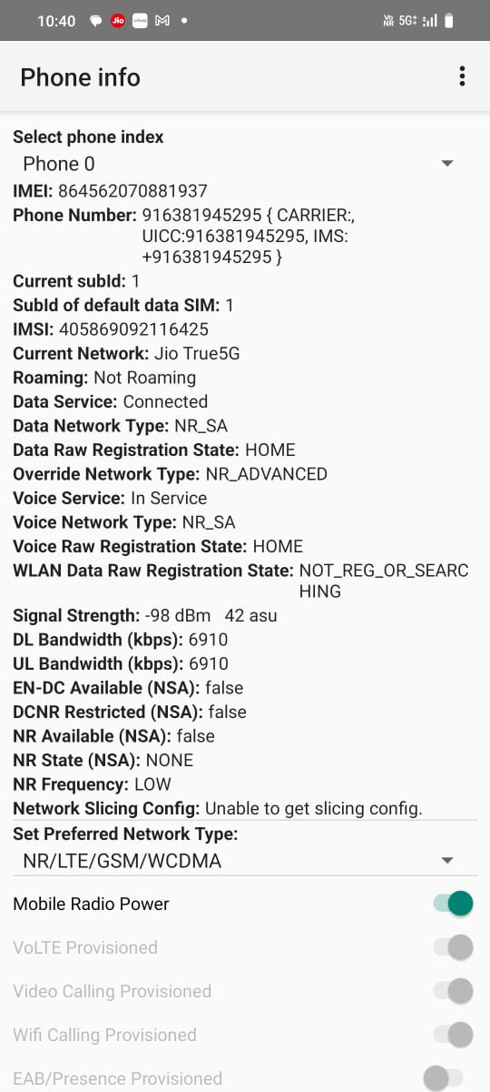

**IMEI Number (International Mobile Equipment Identity)**

* **IMEI:**

A unique 15-digit identifier for mobile devices. It helps network operators track a device on their network, especially useful for identifying stolen phones or blocking devices.

**MAC Address (Media Access Control address)**

* **MAC Address:**

A unique identifier for your device's network interface card (NIC) used in local network communication. It’s essential for device identification within a network, like Wi-Fi or Ethernet. Each device connected to a network has a unique MAC address.

**IP Address (Internet Protocol address)**

An IP address (Internet Protocol address) is a unique identifier assigned to each device connected to a network (like the internet or a local network)

**Network Operator/Brand:**

* **JIO** It’s the company that gives you access to the mobile network, enabling calls, text messages, and internet access.

**Network Type (4G LTE)**

* **5G LTE** refers to the **fifth generation of mobile network technology**, which delivers significantly higher speeds, lower latency, and better capacity than 4G LTE. **LTE (Long-Term Evolution)** is a standard for wireless broadband communication, and when combined with 5G, it optimizes the speed and performance of mobile data.

**Signal Strength (Measured in dBm)**

* **Signal Strength:** A measure of the signal level received by your device, expressed in decibels relative to 1 milliwatt (dBm). In mobile networks, values around -50 dBm represent excellent signal strength, while values below -90 dBm indicate poor reception.

**Download/Upload Bandwidth (Physical channel configuration and speed)**

This would typically represent the available bandwidth and connection speed of your mobile device, measured in megabits per second (Mbps). However, specific details are missing in your input.

**Mobile Location Information (LAC - Location Area Code and CID - Cell ID)**

**LAC:**

Location Area Code, a unique identifier for a geographical area covered by a cellular network. It helps the network identify where you are.

**CID:**

Cell ID, a unique identifier for the specific cell tower your device is connected to. This information helps locate which specific tower you are communicating with.